# **Full Stack Web Developer Test Task**

Develop a mini web-app consist of two pages:

## login form

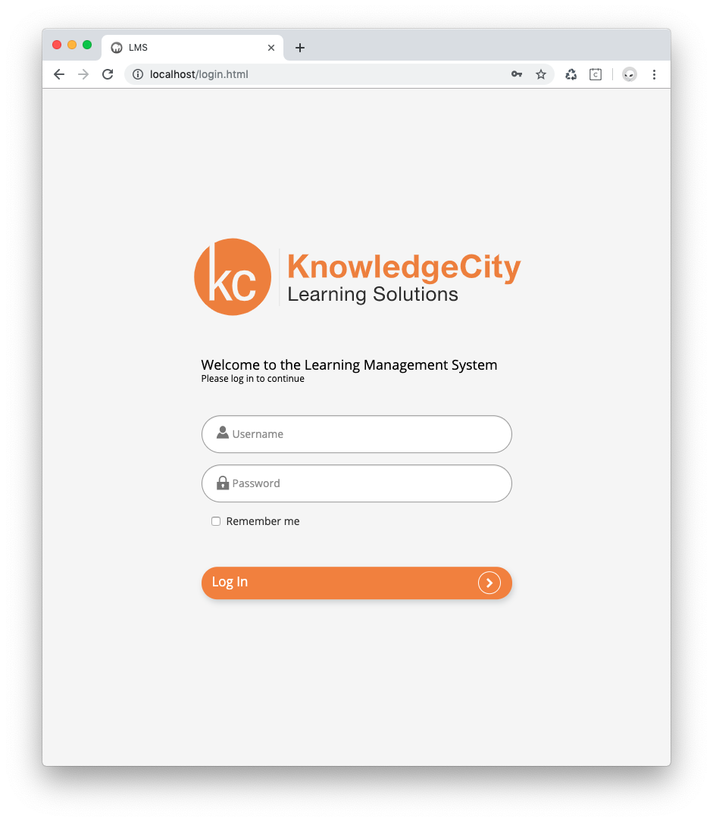

## User List

1. Every page is to be pure HTML/CSS and JavaScript (must be a *.html file, not *.php). It is ok to use bootstrap and jQuery if you like.
2. It is forbidden to use any frameworks in the backend - only pure PHP.
3. Develop simple RESTful API using PHP 7+ which would have 3 resources:  
     
   ***POST /auth*** -- to authenticate user  
     
   ***GET /users*** -- to output list of users with pagination  
     
   ***DELETE /auth*** -- to logout user
4. Develop MySQL database with at least two tables (if you need more tables, feel free to create them)  
     
   ***api_users*** -- table to store username and password which is used to log in to the app  
     
   ***students*** -- list of people which to be shown once user is logged in
5. Notes:  
   1. in the login form, when user clicks "Log In" button, it should send AJAX POST request to /auth API resource to authenticate the user. If authentication fails, user should see an error message.
   2. if "remember me" checkbox is checked then implement remember me functionality so closing browser and reopening, user is still logged in, if they checked that.
   3. if login succeeded, redirect user to the User List page.
   4. in the User List page show 5 records per page. Add more than 5 records to the DB table to enable pagination
   5. API resource GET /users should only return data to authorized users. If user is not authorized and go directly to the User List page it should not list the users and should redirect to login screen
   6. when user clicks "log out" it should send request to DELETE /auth resource to log out the user and redirect user to the login page.

## Example

See the video to get an idea of what should be in the final result:

<https://www.youtube.com/watch?v=jTx76x8eASA>

## Assets

Find assets in the archive here:

<https://drive.google.com/file/d/1xG13NHVVdnx_uPpJoSvMcHJkXpOmRSRC/view?usp=sharing>

## Result

To submit the task either push it to a GIT repository and share a link. Include MySQL DataBase dump (*.sql) file in the files which you are submitting.

Make sure to include README.md file with description of the steps required to configure your application in my environment (how to configure DataBase connection and other steps which might be required to make it run in my local Apache web server)